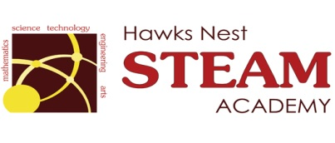 School Counseling Program Newsletter
Shandrai Silva, School Counselor | September 2018

Counselor Message  The 2018-19 school is underway and we’ve gotten off to a great start! I am excited about this school year. I hope you are!  So far, I have had the opportunity to meet with students through classroom guidance. I look forward to meeting with students in small groups and individual meetings as well. The school counseling program will continue to facilitate school programming and initiatives, like school-wide service project and recognition days. I welcome any feedback or ideas regarding the school counseling program.  ____________________________  How to see the school counselor  Classroom guidance classes, small group counseling and individual counseling by self -referral, parent referral, teacher referral, administrator referral or counselor initiated.  Feel free to contact school counselor, Shandrai Silva @ sosilva@gaston.k12.nc.us and/or 704-866-8467.    September 15th – October 15th | Home of the Hawks  Happenings @ the Nest  *International Dot Day*  Join us in celebrating International Dot Day, a global celebration of creativity, courage and collaboration on Friday, September 14th by wearing dots.  Birthed from The Dot by Peter Reynolds, International Dot Day encourages students to trust their own abilities by being brave enough to “make their mark” and embark on a journey of creativity, confidence and self-discovery. Students @ Hawks Nest will make their mark by participating in a schoolwide service during classroom guidance. We’re making greeting cards for members of our community.  http://www.thedotclub.org/dotday/get-started  *International Day of Peace   September 21st – wear white https://internationaldayofpeace.org/get-involved/ | Character Education  “We’re Soaring with Good Character”  _______________________________ The character trait of the month is Responsibility. Responsibility means taking care of your duties; answering for your actions; being accountable and trustworthy. Students will learn more about responsibility through morning announcements and classroom activities.  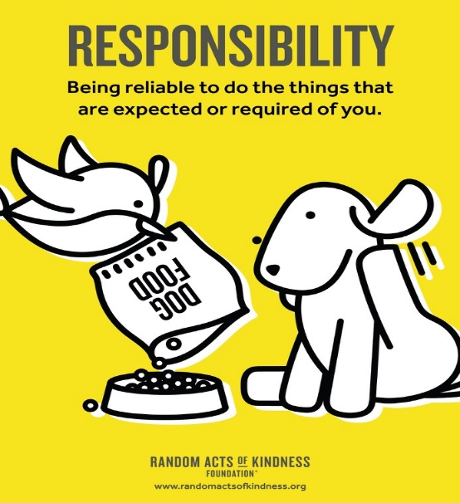  “Intelligence plus character- that is  the goal of true education.”  Dr. Martin L. King, Jr.  _____________________________________  